Project 6 Write Up

1. What we did: HaProxy, Travis CI, Selenium, and JMeter
   * + Notes on Selenium tests: Only two of the tests were functional because when the link clicked to view the ‘Create New Item’ was clicked, it kept going to the ‘Log in’ page instead. We couldn’t figure out the problem in office hours, so you said having the first 2 tests was enough. Most of the 3rd test is commented out so it will pass, but you can still see the code.
2. The updated docker-compose.yml can be accessed through the GitHub link.
3. The GitHub link for the release is included in the email body. (It’s the same as the Project 7 link.)
4. Sample output
   1. HaProxy:

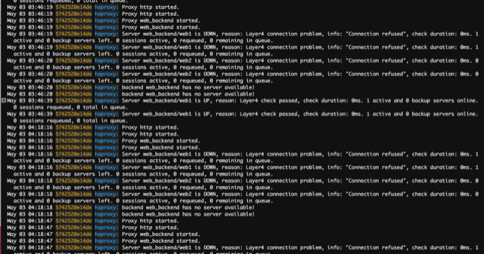

* 1. Travis CI:

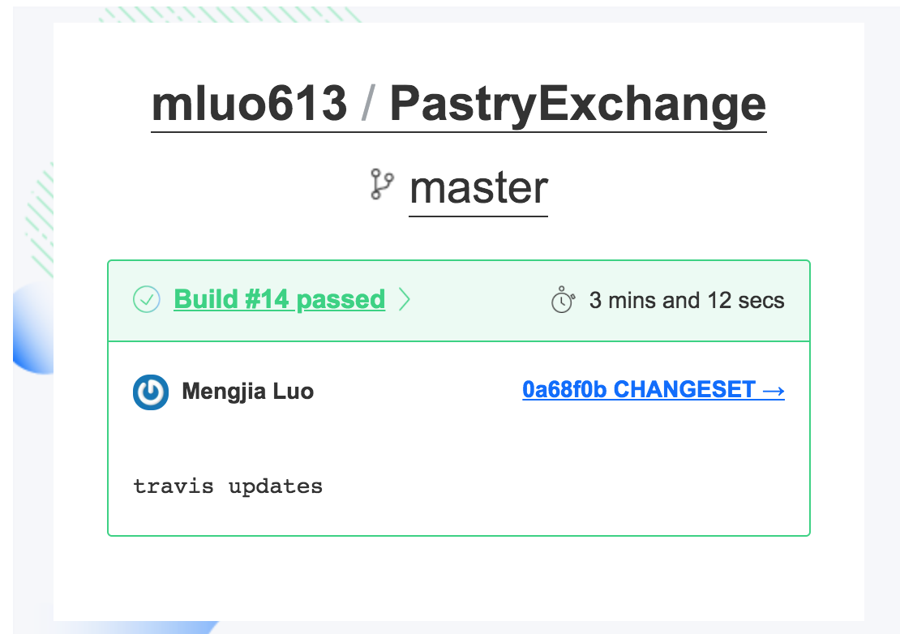

* 1. JMeter:

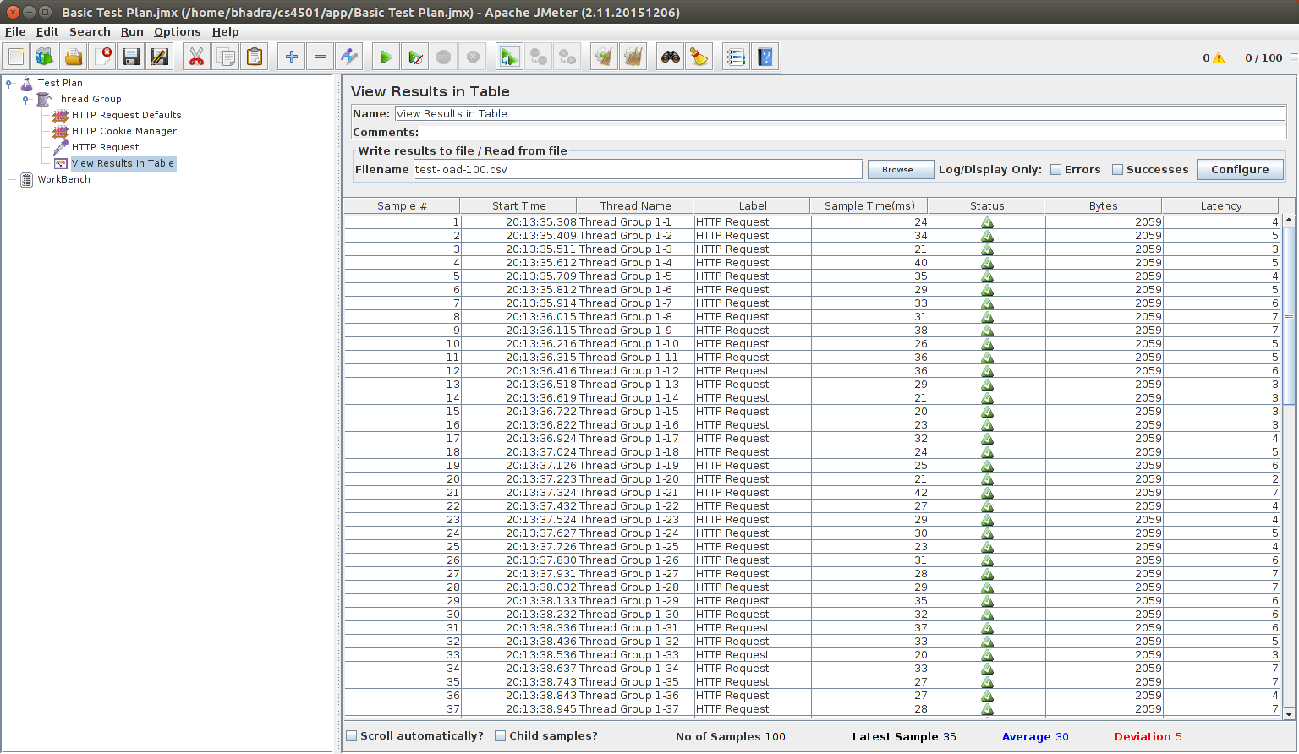

* 1. Selenium:

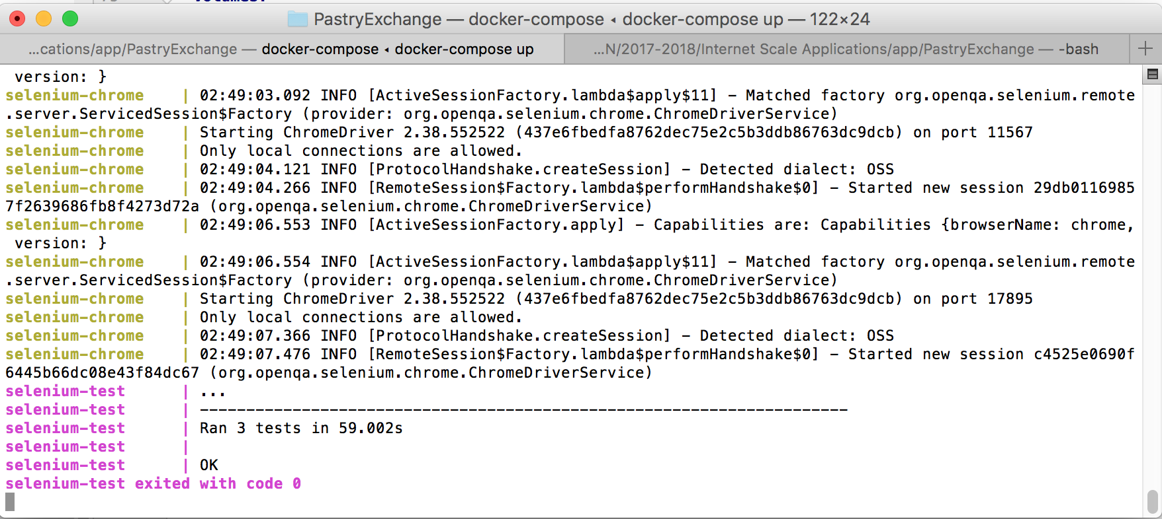

1. No command lines